

**DEDAN KIMATHI UNIVERSITY OF TECHNOLOGY**

**DEPARTMENT OF ELECTRICAL AND ELECTRONIC ENGINEERING**

**FINAL YEAR PROJECT PROPOSAL**

**PROJECT TITLE: IDENTIFYING UNROADWORTHY VEHICLES CAUSING AIR POLLUTION USING IOT SYSTEMS.**

| **Registration No.** | **Name** | **Signature** |
| --- | --- | --- |
| E020-01-0599/2019 | Benjamin Macharia Muthui |  |
| E020-01-2167/2019 | Kelvin Michuki Mwangi |  |
| E020-01-1051/2019 | Monicah Wanjiku Njoroge |  |

**SUPERVISOR: DR. JOSEPH MUGURO**

A proposal submitted to the Department of Electrical and Electronics Engineering in partial fulfillment of the Award of Degree of Bachelor of Science in Telecommunications and Information Engineering.

**NOVEMBER 2023**

## DECLARATION

This project is my original work, except where due acknowledgement is made in the text, and to the best of my knowledge has not been previously submitted to Dedan Kimathi University of Technology or any other institution for award of degree or diploma.

NAME: BENJAMIN MACHARIA REG NO: EO20-01-0599/2019

SIGNATURE: ………………………… DATE:…………………………………………

NAME: KELVIN MWANGI REG NO: EO20-01-2167/2019

SIGNATURE: ………………………… DATE:………………………………………………

NAME: MONICAH WANJIKU NJOROGE REG NO: EO20-01-1051/2019

SIGNATURE: ………………………… DATE:………………………………………………

**SUPERVISOR’S CONFIRMATION**

This project has been submitted to the department of Electrical and Electronics Engineering, Dedan Kimathi University of Technology with my approval as the university supervisor.

NAME: DR. JOSEPH MUGURO

SIGNATURE: …………………………………….. DATE……………………………………………………..

# TABLE OF CONTENTS

Table of Contents

DECLARATION 2

TABLE OF CONTENTS 4

LIST OF ABBREVIATIONS 7

LIST OF DIAGRAMS 8

LIST OF TABLES 9

ABSTRACT 10

CHAPTER 1: INTRODUCTION 1

1.1 BACKGROUND STUDY 1

1.2 PROBLEM STATEMENT 2

1.3 JUSTIFICATION 2

1.4 OBJECTIVES 3

1.4.1 Main Objective 3

1.4.2 Specific Objectives 3

1.5 SCOPE OF STUDY 3

CHAPTER 2: LITERATURE REVIEW 4

2.1 INTRODUCTION 4

2.2 CLIMATE CHANGE AND AIR POLLUTION 4

2.3 EXISTING REGULATORY FRAMEWORKS AND EMISSION STANDARDS 4

2.4 TECHNOLOGIES FOR EMISSION MEASUREMENT 6

2.4.1. ESP32 TTGO T-CAMERA MODULE. 6

2.4.2. MOTION SENSING 7

2.4.2 IMAGE RECOGNITION AND PROCESSING. 9

2.4.2.1 Image Processing and Feature Extraction 11

2.4.2.2 Vehicle Recognition and Classification. 11

2.4.2.3 Real-Time Processing and Inference. 11

2.4.2.4 Continuous Learning and Model Updates. 11

2.4.2.5 Integration with IoT System 11

2.4.3. CO2 SENSING. 12

2.4.4 INTEGRATION WITH IoT PLATFORMS. 13

2.5 RESEARCH GAP 14

1. Technological approach 14

2. Different contexts 14

CHAPTER 3: METHODOLOGY 15

3.1 USING SENSOR TECHNOLOGIES AND CAMERAS TO COLLECT DATA WHICH INCLUDE IMAGES AND CARBON (II) OXIDE LEVELS. 15

3.1.1 HARDWARE AND SOFTWARE SETUP 15

3.1.1.1 HARDWARE SETUP 15

3.1.1.2 FIRMWARE (SOFTWARE) DEVELOPMENT 17

3.2 INTEGRATING IMAGE PROCESSING BY USE OF CNN MACHINE LEARNING MODEL TO INTERPRET AND PROCESS IMAGES.. 18

3.2.1 Dataset Collection and Preparation: 18

3.2.2 Model Selection and Architecture: 18

3.2.3 Transfer Learning: 18

3.2.4 Data Augmentation: 18

3.2.5 Model Training: 19

3.2.6 Model Evaluation and Fine-tuning: 19

3.2.7 Model Deployment onto Google Firebase 19

3.3 TO INTRODUCE AN IOT SYSTEM FOR DATA PROCESSING, ANALYSIS OF DATA COLLECTED AND STORAGE. 19

3.3.1 Data Collection and Transmission: 19

3.3.2 Server/Cloud Platform Integration: 20

3.4 OVERVIEW OF PROPOSED METHODOLOGY 20

CHAPTER FOUR : RESULTS AND DISCUSSION **21**

4.1 USING SENSOR TECHNOLOGIES AND CAMERAS TO COLLECT DATA WHICH INCLUDE IMAGES AND CARBON (II) OXIDE LEVELS. 21

4.1.1 Hardware setup 22

4.1.2 Software setup 22

4.2 INTEGRATING IMAGE PROCESSING BY USE OF CNN MACHINE LEARNING MODEL TO INTERPRET AND PROCESS IMAGES. 23

4.3 TO INTRODUCE AN IOT SYSTEM FOR DATA PROCESSING, ANALYSIS OF DATA COLLECTED AND STORAGE. 25

CHAPTER FIVE : CONCLUSION AND RECOMMENDATION 27

REFERENCES 29

# LIST OF ABBREVIATIONS

IOT - Internet of THings

NDIR - Nondispersive infrared sensor

ESP32 - Espressif Systems with a series of SOC and modules

SOC - System on a Chip

WHO - World Health Organization

UNEP - United Nations Environment Programme

C02 - Carbon(IV)Oxide

GSM – Global System for Mobile Communication

# LIST OF DIAGRAMS

Figure 1 - Smog over Nairobi

Figure 2 - ESP32 TTGO T-CAMERA

Figure 3 – Phases in Pattern Recognition

Figure 4 - Nyeri-Nyahururu Highway

Figure 5 - Overview of the Proposed Methodology

# LIST OF TABLES

# ABSTRACT

This project is outlining a detailed framework for addressing the challenge of air pollution caused by unroadworthy vehicles in the context of climate change. The project intends to use IoT systems to figure out and mitigate the extreme environment effects caused by such vehicles. Integration of sensor technologies, real-time monitoring, the proposed solution seeks to promote sustainable transport practices, improve air quality and reduce greenhouse gas emissions.

Through the deployment of IoT sensors on roads relevant to the area of research, relevant details on level of emissions of carbon fuels will be retrieved. The IoT sensors will be activated once the motion sensors are triggered by oncoming vehicles and a photo of the vehicles will be taken by strategically positioned cameras and will contain a timestamp that will be necessary during evaluation of different levels of carbon emissions at different time intervals. The carbon emission levels will be transmitted to a database.

By leveraging this analysis, the system will identify polluting and unroadworthy vehicles, categorize them based on the emission levels and assess their compliance with environmental regulations. Introduction of image processing in the machine learning field will help in identifying levels of fumes visible by the photo.

Additionally, a user-friendly interface will be implemented to provide relevant stakeholders with access to visualized data, enabling them to monitor emission levels, track vehicle compliance and make informed decisions pertaining to sustainable transportation practices. This will go a long way in dealing with the adverse effects of climate change.

# CHAPTER 1: INTRODUCTION

## BACKGROUND STUDY

According to a pollution study in the UK as much as 97% percent of all Carbon Dioxide emissions in major cities such as London come from motor vehicle exhaust. One wonders what pollutant levels Nairobi residents are inhaling given our lack of controls on vehicle emissions. Research by the World Health Organization (WHO) indicates that outdoor urban air pollution, mostly from vehicles and factories, accounts for premature deaths of 1,340,000 people worldwide annually. To put it in visualization, it is as if 55 buses carrying 65 passengers crash daily with no survivors. Sounds extreme right? Research is increasingly showing that car and industrial pollution are linked to cancer, cardiovascular diseases and respiratory illnesses such as asthma. Air pollution in Third-world countries especially Africa is a great pandemic as the deaths caused by air pollution from vehicles may surpass deaths caused from road accidents.

In Kenya, UNEP estimates that 90% of urban air pollution in rapidly growing cities like Nairobi comes from motor vehicles. The number of levels of pollutants found along Nairobi roads exceed the recommended WHO levels.

As per UNEP’s recommendations , African governments could prevent 200,000 premature deaths per year by 2030 and 880,000 deaths per year by 2063 in the following ways; reduce carbon dioxide emissions by 55%, methane emissions by 74%, and nitrous oxide emissions 40% by 2063; improve food security by reducing desertification and increasing crop yields for rice, maize, soy, and wheat; and contribute significantly to global efforts to keep warming below 1.5°C, limiting the negative effects of regional climate change.

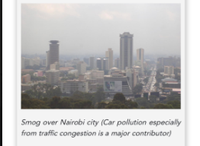

*Figure 1: smog over Nairobi city*

## PROBLEM STATEMENT

Increasing pollution levels due to the presence of unroadworthy vehicles pose significant challenges to environmental sustainability and public health. Unroadworthy vehicles are classified by faulty engines, excessive emissions, or inadequate safety features. The current methods of identifying and addressing polluting and unroadworthy vehicles are often inefficient, time-consuming, and rely on manual inspection processes. To tackle this problem, the integration of IoT devices offers a more reliable approach. By connecting sensors such as PIR motion sensors, NDIR CO2 sensors, and image processing modules, researchers can collect real-time data on vehicle movements, emissions, and overall roadworthiness.

However, several challenges must be overcome, including ensuring sensor accuracy and reliability, processing and analyzing the collected data, achieving seamless integration and scaling of the system for widespread deployment. By addressing these challenges, an IoT-based system can facilitate the identification of unroadworthy vehicles, enabling timely intervention and enforcement measures to mitigate air pollution.

## JUSTIFICATION

The project on identifying unroadworthy vehicles causing air pollution using an IoT system is highly justified due to the urgent need to tackle air pollution. Air pollution poses severe health and environmental risks. Traditional methods of vehicle inspection and enforcement are limited in their effectiveness. This makes it necessary to integrate IoT technology for a more efficient approach. By integrating IoT devices such as PIR motion sensors, NDIR CO2 sensors and image processing modules real-time data collection and advanced analysis can be achieved. This enables continuous monitoring of vehicle emissions and roadworthiness, leading to time-based identification and enforcement of unroadworthy vehicles.

Additionally, the project aligns with the global sustainability agenda, contributing to the development of intelligent transportation systems and smart cities. The outcomes of the project have the potential to significantly reduce air pollution, improve air quality, and support a more sustainable future, benefitting both public health and the environment.

## OBJECTIVES

### 1.4.1 Main Objective

To identify air pollution caused by unroadworthy vehicles using IoT systems and Machine Learning.

### 1.4.2 Specific Objectives

1. Using sensor technologies and cameras to collect data which include images and Carbon (II) Oxide levels

2. Integrating image processing by use of CNN machine learning model to interpret and process images.

3. To introduce an IoT system for data processing, analysis of data collected and storage.

## SCOPE OF STUDY

The scope of this research proposal focuses on the identification of unroadworthy vehicles that contribute to air pollution using IoT devices. The study entails the integration and application of various sensor technologies, including PIR motion sensors, NDIR CO2 sensors, image processing and GSM communication to develop a comprehensive monitoring and alert system. The integration of GSM technology will enable real-time communication, alert systems and remote monitoring capabilities which will enhance the overall effectiveness of the proposed system.

The study aims to address the challenges associated with traditional vehicle inspection methods and provide a more efficient and accurate approach to identifying unroadworthy vehicles.

The study will also involve the design and implementation of an IoT-based system that collects real-time data on vehicle emissions and overall roadworthiness. The integration of IoT devices will enable continuous monitoring, data acquisition, and analysis. The research will focus on optimizing sensor accuracy, developing efficient data processing algorithms, and ensuring the security and privacy of collected data. The scope also includes the evaluation of the system's performance in terms of identification accuracy, response time, and scalability.

Furthermore, the research will explore the potential application of machine learning algorithms for data analysis and pattern recognition. By leveraging advanced analytics techniques, the study aims to identify specific patterns and anomalies associated with unroadworthy vehicles and high levels of air pollution.

# CHAPTER 2: LITERATURE REVIEW

## 2.1 INTRODUCTION

Air pollution is a significant environmental issue with detrimental effects on public health and the environment. Unroadworthy vehicles contribute significantly to air pollution, emitting higher levels of pollutants due to mechanical faults and outdated emission control technologies. This literature review focuses on the project of identifying air pollution caused by unroadworthy vehicles using Internet of Things (IoT) systems integrated with sensors. It explores existing literature to understand the methodologies, technologies, and findings of studies that have utilized IoT-based approaches for monitoring and addressing this problem.

## 2.2 CLIMATE CHANGE AND AIR POLLUTION

Pollutants not only greatly affect public health, but also the earth’s climate and ecosystems globally. Reducing air pollution offers a “win-win” strategy for both public health and climate change. Common sources of air pollution and climate change pollutants are high C02 emissions. That is fossil fuels for power generation, industry and unroadworthy vehicles, with unroadworthy vehicles being the highest source of C02 emissions.

At the Integrated Assessment of Air Pollution and Climate Change for Sustainable Development in Africa held in Sharm el-Sheikh, Egypt on 17th November 2022, the United Nations Environment Programme (UNEP) and the African Union Commission showed how Africa could prevent 880,000 deaths per year by 2063 and 200,000 premature deaths per year by 2030 by acting quickly across 5 key areas; transport, residential energy, agriculture and waste.

“Air pollution is a climate and health emergency, in Africa and around the world. By cutting short-lived climate pollutants, we can slow down the worst effects of climate change in the very near term while protecting human lives. We must come together to work with African nations to reduce emissions from short-lived climate pollutants and eliminate air pollution as much as possible this decade,” said Inger Andersen, Executive Director of UNEP.

## 2.3 EXISTING REGULATORY FRAMEWORKS AND EMISSION STANDARDS

The Kenyan body in charge of transport regulations and oversight, NTSA,enforces Motor Vehicle Components and Accessories Technical Committee under the guidance of the Mechanical Industry Standards Committee policies.The current standard emission test during inspection requires that the concentration of carbon monoxide (CO) shall not exceed 0.5 per cent volume and hydrocarbons (HC) concentrations shall not exceed 0.12 per cent volume (1 200 ppm). This body ensures that tests are conducted on motor vehicles i.e. Idling, 10.15-mode and 11 mode exhaust emission tests. This is a mode of testing that has been popular in Japan. Due to the fact that the majority of the cars imported are Japanese, Kenya has sought for implementation of this very model of testing.A brief test as used is the 10-15 mode cycle that had been used in Japan for emissions and fuel economy testing for light duty vehicles. Over the period of 2008-2011, the test was gradually replaced by the newer JC08 cycle.

The 10-15 Mode test is derived from the 10 mode cycle by adding another 15-mode segment of a maximum speed of 70 km/h. Emissions are expressed in g/km [Japanese Industrial Safety and Health Association, JISHA 899, 1983].

The entire cycle includes a sequence of a 15 minute warm-up at 60 km/h, idle test, 5 minute warm-up at 60 km/h, and one 15-mode segment, followed by three repetitions of 10-mode segments and one 15-mode segment. Emissions are measured over the last four segments (3×10-mode + 1×15-mode)

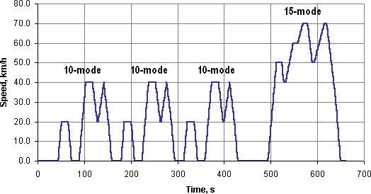

*Figure 2: 10-15 cycle*

Japanese 2005 emission regulation introduced a new JC08 chassis dynamometer test cycle for light vehicles (< 3500 kg GVW). The test represents driving in congested city traffic, including idling periods and frequently alternating acceleration and deceleration. Measurement is made twice, with a cold start and with a warm start. The test is used for emission measurement and fuel economy determination, for gasoline and diesel vehicles. All the processes involved in the 10-15 Mode test occur during manual vehicle inspection that is unautomated.

Similarly Hong Kong has modified the same and narrowed it down to detection of carbon monoxide, nitrogen oxide and hydrocarbon levels in tailpipe exhausts of passing vehicles. Need for implementation of machine learning is crucial based on a number of reasons:

* Majority of the roads in third world countries are A2 roads and congestion is the norm as there is high level emission within the small area allocated for the road.
* In addition, the roads are at times occupied by other parties such as pedestrians,animals crossing the roads or even still, cyclists.
* Due to the challenges mentioned above, our proposal goes miles ahead by incorporating k-means clustering CNN machine learning model for image processing. This will enable differentiation between motor vehicles and non motor vehicles. Technologies listed below further delve into the modernization and improvement of the existing systems for automation.

## 2.4 TECHNOLOGIES FOR EMISSION MEASUREMENT

Below are the respective technologies used;

### 2.4.1. ESP32 TTGO T-CAMERA MODULE.

The integration of the ESP32 TTGO T-Camera module adds significant value to the proposed research on the identification of unroadworthy vehicles that contribute to air pollution using IoT devices. This section focuses on the application of the ESP32 TTGO T-Camera module, in conjunction with other sensor technologies and IoT capabilities discussed in the literature review, to enhance the accuracy and efficiency of the vehicle identification process. By incorporating this module, researchers can leverage its advanced features, including image capture, processing, and wireless communication, to achieve identification of unroadworthy vehicles.It consists of a PIR motion sensor, 0V2640 camera and microprocessor.

1. Image Capture and Processing: The ESP32 TTGO T-Camera module is equipped with a high-resolution camera sensor, allowing for the capture of images or video streams of vehicle movements and behaviors. This capability enables researchers to obtain visual data for subsequent analysis and vehicle identification. The module's onboard image processing capabilities, including face detection and recognition algorithms, can be utilized to extract vehicle-specific features, enhancing the accuracy of identification and classification.
2. Wireless Communication: The ESP32 TTGO T-Camera module supports various wireless communication protocols, including Wi-Fi and Bluetooth, allowing seamless connectivity and data transmission. Real-time vehicle identification results, captured images, and other relevant data can be wirelessly transmitted to a central server or cloud platform for further analysis. This wireless communication capability enables remote monitoring, data sharing, and collaboration among researchers and stakeholders involved in air pollution control efforts.
3. Data Storage and Logging: The module incorporates flash memory, providing storage capabilities for captured images, sensor data, and identification results. Researchers can log relevant data on the device itself, facilitating offline operation and ensuring data integrity in case of network connectivity issues. This feature allows for continuous data collection even in areas with limited network coverage, ensuring a robust and uninterrupted monitoring system.
4. Power Efficiency and Portability: The ESP32 TTGO T-Camera module is designed to be power-efficient, enabling extended operation even in battery-powered scenarios. Its compact size and lightweight nature make it highly portable, allowing researchers to deploy the module in various locations for comprehensive air pollution monitoring. The module's power efficiency and portability contribute to its suitability for long-term monitoring applications and field deployments.
5. Compatibility and Customization: The ESP32 TTGO T-Camera module is based on the ESP32 microcontroller, providing compatibility with the Arduino programming environment and a wide range of existing libraries and frameworks. Researchers can leverage this compatibility to customize and extend the functionality of the module based on their specific requirements. Additionally, the module's open-source nature encourages community collaboration and the development of additional features and capabilities.

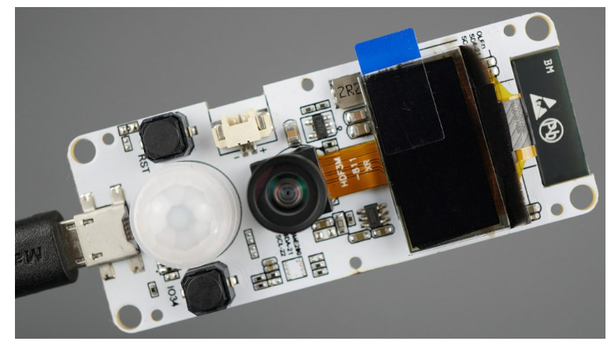

*Figure 3 : ESP32 TTGO T-Camera*

### 2.4.2. MOTION SENSING

Motion Sensing Technologies: Various motion sensing technologies have been utilized in the identification of unroadworthy vehicles. These include Global Positioning System (GPS), accelerometer-based sensors, and image processing techniques. Each technology provides unique advantages and capabilities for accurately tracking vehicle movements and behaviors. In our case, motion sensors with the help of image processing techniques that trigger the camera and carbon monoxide sensors are our areas of interest.

Motion sensors have evolved overtime. One of the first applications of motion sensing outside the military was developed by Samuel Bagno in the mid-1940s. Using his knowledge of radar and newly developed electrical components, Bagno began doing research on an ultrasonic alarm, which worked similarly to radar. Infrared sensors are passive; this means that instead of having to emit energy to detect changes, they are capable of detecting radiation emitted by other objects, such as thermal energy from human beings.

Infrared sensors are made from different materials that sense different ranges of infrared wavelengths. When an appropriate wavelength of infrared radiation strikes one of the material’s cells, it changes the cell’s resistance. By measuring the resistance of the cell, one can measure its infrared radiation. Since many different objects, both living and inert, emit a certain level of infrared radiation, it is convenient for the sensors to detect rapid changes in infrared radiation instead of a particular wavelength. This way, a human being can still be detected through the slow change in atmospheric temperature. When a sensor detects a rapid change, a device is triggered to either start or stop working. One example is a motion sensor porch light, in which the sensor detects a sudden change in infrared radiation and triggers the light to turn on.

The integration of motion sensing technologies is crucial in the identification of unroadworthy vehicles that contribute to air pollution using Internet of Things (IoT) devices. This section focuses on the application of Passive Infrared (PIR) motion sensors and their role in detecting vehicle movement patterns. PIR sensors are widely used in various domains for motion detection due to their effectiveness, low cost, and energy efficiency. By incorporating PIR sensors into IoT devices, researchers can enhance the accuracy and reliability of identifying unroadworthy vehicles based on their motion-related behaviors.

#### 2.4.2.1 Passive Infrared (PIR) Motion Sensor

Principle of Operation: PIR sensors detect changes in infrared radiation emitted by objects within their detection range. The sensors consist of two pyroelectric elements that generate an electrical signal when exposed to variations in temperature caused by the movement of objects. The sensor's lens is designed to focus on a specific area, allowing it to capture movement within its field of view.

#### 2.4.2.2 Integration with IoT Devices

PIR sensors can be seamlessly integrated into IoT devices, such as cameras or monitoring systems, to detect and track vehicle movements. When a PIR sensor detects a change in infrared radiation, it triggers a signal that initiates data collection and analysis. This data, combined with other sensor data (e.g., GPS, accelerometers), provides comprehensive information about vehicle motion patterns and behaviors.

#### 2.4.2.3 Detection of Vehicle Movement:

Vehicle Presence and Traffic Monitoring: PIR sensors can detect the presence of vehicles within their detection range. By strategically placing sensors at specific locations, such as road intersections, parking areas, or toll booths, researchers can monitor the flow of vehicles and identify unroadworthy vehicles that deviate from expected patterns. The detection of abnormal vehicle movements can trigger further analysis and investigation.

#### 2.4.2.4 Data Analysis and Integration

The data collected from PIR sensors can be combined with other sensor data to gain comprehensive insights into vehicle behaviors and roadworthiness.

### 2.4.2 IMAGE RECOGNITION AND PROCESSING.

The integration of image processing with ESP32 TTGO T-CAMERA’s Passive Infrared (PIR) motion sensors and the 0V2640 camera enhances the identification of unroadworthy vehicles that contribute to air pollution using IoT devices. This section focuses on the correlation between image data and PIR motion sensor data, offering a comprehensive approach to detect vehicle movements and assess roadworthiness. By combining these two technologies, researchers can achieve higher accuracy in identifying unroadworthy vehicles, leading to more effective measures for mitigating air pollution.

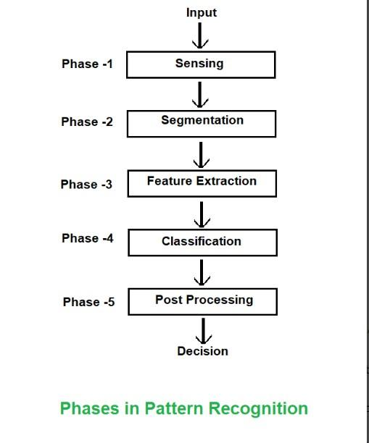

*Figure 4: Phases in pattern recognition*

The process of Image recognition and processing can be made possible by use of the CNN machine learning model. The utilization of Convolutional Neural Networks (CNNs) as a machine learning model enhances the image processing and recognition capabilities in the proposed research on identifying unroadworthy vehicles causing air pollution using IoT devices. This section focuses on the application of CNNs, in conjunction with image processing techniques and IoT capabilities, to improve the accuracy and efficiency of vehicle recognition. By incorporating CNNs, researchers can leverage their ability to learn and identify complex patterns in images, enabling more accurate identification of unroadworthy vehicles.

### 2.4.2.1 Image Processing and Feature Extraction

CNNs excel in image processing tasks, allowing researchers to extract relevant features from vehicle images captured by the ESP32 TTGO T-Camera module. Through a series of convolutional and pooling layers, CNNs can automatically learn and detect important visual patterns, such as vehicle shapes, colors, and distinctive features such as smoke emitted by vehicles. This feature extraction process enhances the representation of vehicle images, enabling more effective identification and classification of unroadworthy vehicles based on their visual characteristics.

### 2.4.2.2 Vehicle Recognition and Classification.

By training a CNN model with a labeled dataset of vehicle images, researchers can develop a robust vehicle recognition system. The trained CNN model can accurately classify vehicle images into different categories, such as cars, motorcycles, trucks, or specific vehicle models. This recognition capability enables the identification of unroadworthy vehicles in real-time, based on their visual appearance. By also including smoke segmentation, it is made possible to classify the vehicle as smoky or non-smoky based on the presence of smoke captured by the camera. The integration of CNNs in the proposed research enhances the accuracy and reliability of vehicle identification, minimizing false positives and false negatives.

### 2.4.2.3 Real-Time Processing and Inference.

Google Firebase platform offers custom machine learning capabilities whereby the captured images are inferenced on the platform via the uploaded model. Machine learning models trained to recognize vehicle characteristics, such as license plates or specific vehicle types, can be deployed on the platform, facilitating real-time identification of unroadworthy vehicles. This integration of machine learning and AI capabilities enhances the system's accuracy and reliability in identifying vehicles contributing to air pollution.

### 2.4.2.4 Continuous Learning and Model Updates.

The integration of CNNs allows for continuous learning and model updates. Researchers can periodically retrain the CNN model using new labeled datasets or additional vehicle images to improve its performance over time. This continuous learning approach ensures that the vehicle recognition system remains adaptive and capable of accurately identifying new vehicle models or variations in vehicle appearances, enhancing the system's long-term effectiveness.

### 2.4.2.5 Integration with IoT System

The CNN model can be seamlessly integrated into the IoT system architecture. The ESP32 TTGO T-Camera module, along with its connectivity capabilities, allows for real-time image capture, processing, and inference using the trained CNN model. The integration of CNNs with the IoT system enhances the overall functionality and efficiency of vehicle recognition, enabling accurate identification of unroadworthy vehicles in real-world scenarios.

### 2.4.3. CO2 SENSING.

The integration of Non-Dispersive Infrared (NDIR) CO2 sensors enhances air pollution monitoring and the identification of unroadworthy vehicles using IoT devices. This section focuses on the application of NDIR CO2 sensors in conjunction with other sensing technologies, such as PIR motion sensors and image processing. By incorporating NDIR CO2 sensors into the proposed research, researchers can obtain real-time CO2 concentration data, correlate it with vehicle movements, and identify high-emitting unroadworthy vehicles contributing to air pollution

#### 2.4.3.1 Real-Time CO2 Monitoring.

NDIR CO2 sensors provide real-time measurements of carbon dioxide (CO2) concentrations in the surrounding environment. By integrating NDIR CO2 sensors into IoT devices, researchers can continuously monitor CO2 levels and identify areas of high pollution, particularly those influenced by vehicle emissions. This real-time monitoring helps establish a comprehensive understanding of air pollution patterns and enables timely intervention measures.

#### 2.4.3.2 Vehicle Emission Tracking.

The integration of NDIR CO2 sensors with IoT devices allows for the tracking of vehicle emissions in real-time. By strategically placing sensors in high-traffic areas or near roadways, researchers can measure CO2 concentrations and correlate them with passing vehicles. This correlation enables the identification of unroadworthy vehicles that emit excessive CO2, aiding in the targeting of enforcement efforts and providing valuable data for air pollution control strategies.

#### 2.4.3.3 Traffic Analysis and Management.

The integration of NDIR CO2 sensors with IoT devices also allows for traffic analysis and management. By monitoring CO2 concentrations at various locations and times, researchers can assess traffic patterns, identify congestion hotspots, and evaluate the impact of traffic flow on air pollution. This data-driven approach supports the development of effective traffic management strategies and promotes environmentally friendly transportation practices.

#### 2.4.3.4 Data Fusion for Comprehensive Insights.

Integrating NDIR CO2 sensor data with data from other sensors, such as PIR motion sensors and image processing, provides a comprehensive understanding of the relationship between vehicle emissions and air pollution. By fusing CO2 concentration data with vehicle detection, tracking, and classification information, researchers can gain valuable insights into the contribution of unroadworthy vehicles to overall pollution levels. This data fusion aids in formulating evidence-based policies and measures for air pollution control.

### 2.4.4 INTEGRATION WITH IoT PLATFORMS.

In addition to the integration of the ESP32 TTGO T-Camera module, the utilization of cloud platforms such as ThingSpeak further enhances the capabilities of the proposed research on identifying unroadworthy vehicles causing air pollution using IoT devices. This section focuses on the application of this cloud platform. ThingSpeak for CO2 readings and Visualization: ThingSpeak, an IoT analytics platform provided by MathWorks, is an excellent solution for storing and managing sensor data. Researchers can utilize ThingSpeak to store the collected data from various sensors, such as CO2 concentrations.This cloud platform offers reliable and scalable storage, ensuring secure preservation of the data for further analysis.

ThingSpeak also provides built-in visualization tools that enable researchers to create custom dashboards and graphs for visualizing the collected data. These visualization features enhance the interpretation process, allowing for a comprehensive understanding of air pollution trends, vehicle behaviors, and the impact of unroadworthy vehicles.

Integration and Compatibility: ThingSpeak is designed to integrate seamlessly with IoT devices and offers compatibility with various programming languages and frameworks. Researchers can leverage this compatibility to develop custom applications or integrate the cloud platform into their existing IoT system. The flexibility of integration allows for a tailored solution that meets the specific requirements of the research project.

Scalability and Performance: ThingSpeak is built to handle large-scale data storage and processing. It offers a scalable solution, enabling researchers to expand the system as needed, accommodating an increasing number of IoT devices and data points. This scalability ensures optimal performance, even when monitoring air pollution in a large geographic area or deploying multiple IoT devices simultaneously.

## 2.5 RESEARCH GAP

There are ongoing projects both implemented and ongoing that are related to this project proposal making it quite feasible and applicable in the real world. An example of this is Hong Kong.Hong Kong has improved its air quality by using roadside sensors to detect vehicles with the dirtiest fumes and forcing owners to get them fixed. New cars have technology for reducing these emissions, but they can become more polluting over time. Many older cars that are still on the roads are heavy emitters. To identify the worst-offending vehicles, Hong Kong installed sensors on highway ramps that use infrared and ultraviolet beams to detect carbon monoxide, nitrogen oxide and hydrocarbon levels in tailpipe exhausts of passing vehicles. Cameras capture the license plates of the most polluting vehicles so their owners can be notified. Owners must repair their vehicles and pass an emissions test, paid for themselves, before their vehicles are allowed back on the road.

The research gap between our project and Hong Kong's is on two aspects:

### Technological approach

The HongKong project uses sensors and cameras for data collection. It is primarily focused on emission levels and license plates. In contrast our project uses image processing in the machine learning field to identify the fumes visible in photos. Image processing poses effectiveness and accuracy compared to direct sensor measurements.

### Different contexts

Honkong’s initiative is implemented in an urban setting with different vehicle landscapes. The model is for multi-lane unidirectional highways. This makes their model not suitable for low-income countries such as Kenya. This is because most roads are bidirectional and single-lane. Honkong’s environmental surroundings are not the same as Kenya where we have other non-vehicle variables on our roads/highways; grazing animals, hawkers, street vendors, cyclists, etc.

# CHAPTER 3: METHODOLOGY

## 3.1 USING SENSOR TECHNOLOGIES AND CAMERAS TO COLLECT DATA WHICH INCLUDE IMAGES AND CARBON (II) OXIDE LEVELS.

## 3.1.1 HARDWARE AND SOFTWARE SETUP

The following will be the required components to carry out the project and collect the data for analysis:

1. HARDWARE:
2. TTGO T-Camera ESP32 camera module with embedded PIR motion sensor.
3. Gas sensors such as the NDIR sensors.
4. Peripherals which include transistors, resistors, breadboard and other required supporting circuitry.
5. Laptop with the following specifications:
6. At least 4GB RAM.
7. At least 2.7GHZ processing speed.
8. At least 500GB HDD.
9. SOFTWARE:
10. Arduino IDE.
11. ESP32 Board Support Package.
12. TTGO T-Camera ESP32 Library.

### 3.1.1.1 HARDWARE SETUP

#### TTGO T-Camera ESP32:

* TTGO T-Camera ESP32 board with built-in microprocessor and OV2640 fish-eye lens camera module.

#### NDIR Sensor:

* Connect the NDIR sensor to the appropriate pins of the TTGO T-Camera ESP32. The pins that will be used on the board will be the GPIO 33.

#### Power Supply:

* Connect a suitable power supply to the TTGO T-Camera ESP32. In this case, the suitable power supply would be the 5V power supply of the laptop USB port.
* Ensure the power supply can provide sufficient power for the TTGO T-Camera ESP32 and NDIR sensor.
* Pay attention to the voltage and current requirements of each component.

#### Display :

* This will be achieved through the built-in OLED display that is present in the TTGO T-Camera ESP32 module. The OLED display has a dark contrast that makes it clearer to display information that will be ongoing such as successful image transfer to the Thingspeak server.

#### Sensor Selection and Connection:

* Choose a suitable gas sensor that is compatible with the TTGO T-Camera ESP32's microprocessor and meets the project's requirements for measuring CO2 levels, temperature, and humidity. We are to use the Non-Dispersive Infrared Sensor(NDIR) from Environment Leading Technology(ELT) due to its effective range, resistance to interference and overall long life.
* Connect the NDIR sensor to the appropriate pins of the TTGO T-Camera ESP32, following the pin configuration specified in the sensor's datasheet. This is the GPIO 21 and the GPIO 22 ports that are available at the ESP32 module.

**BLOCK DIAGRAM/CIRCUIT**

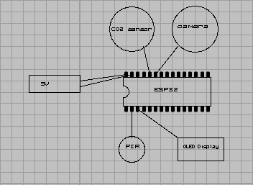

*Figure 5 : Hardware circuit*

### 3.1.1.2 FIRMWARE (SOFTWARE) DEVELOPMENT

Firmware development involves writing software code that runs on the ESP32 module to interact with the gas sensors, process sensor data and facilitate communication with the other devices. It is done in the following steps:

#### 

#### Library or SDK Initialization:

* Identify and utilize the appropriate libraries and software development kit (SDK) to communicate with all required sensors.
* Install the libraries or SDK in the development environment for the ESP32's microprocessor.
* The libraries that are to be used in the Arduino IDE are used to create hardware interactions between the ESP32 and the sensors and platforms. They also provide a standardized and simplified platform to interact with the sensors and platforms.

#### Initialization and Configuration:

* Initialize the NDIR sensor library in the code for the TTGO T-Camera ESP32's microprocessor.
* Configure the sensor's settings, such as measurement range, calibration parameters, and data acquisition frequency, as per the manufacturer's specifications and project requirements.

#### Data Reading and Acquisition:

* Implement functions or methods to read CO2 levels from the NDIR sensor using the NDIR sensor library or SDK.
* Utilize the provided APIs or functions to retrieve the sensor data in the desired format (e.g., numerical values, strings).
* Store the acquired sensor data in appropriate variables or data structures for further processing and transmission.

#### 

## 3.2 INTEGRATING IMAGE PROCESSING BY USE OF CNN MACHINE LEARNING MODEL TO INTERPRET AND PROCESS IMAGES..

#### 

Integrating a Convolutional Neural Network (CNN) into the project can enhance the capability of the TTGO T-Camera ESP32 to identify vehicles.Below is an updated approach to include the CNN integration:

### 3.2.1 Dataset Collection and Preparation:

* Collect a labeled dataset of vehicle images that includes various classes (car, truck, motorcycle, etc.).
* Annotate the images with bounding boxes or segmentation masks to indicate the location of the vehicles.
* Split the dataset into training and validation subsets for model training and evaluation.

### 3.2.2 Model Selection and Architecture:

* Choose a suitable CNN architecture for object detection, such as Faster R-CNN, YOLO, or TensorFlow. In this project, we used the TensorFlow model which offers great compatibility with Google Firebase.
* Select a pre-trained CNN model that matches the chosen architecture to serve as a starting point.

### 3.2.3 Transfer Learning:

* Initialize the chosen CNN model with the pre-trained weights.
* Adapt the model to the vehicle detection task by replacing the classification layers with new ones that match the number of vehicle classes in your dataset.
* Freeze the early layers of the CNN to retain the pre-trained features and fine-tune the later layers for vehicle-specific features.

### 3.2.4 Data Augmentation:

* Apply data augmentation techniques to artificially expand the training dataset.
* Common augmentation methods include random cropping, rotation, flipping, and color transformations.
* Augmentation helps increase the model's robustness and generalization ability.

### 3.2.5 Model Training:

* Feed the training dataset, along with the annotated bounding boxes, into the CNN model.
* Optimize the model using a suitable loss function, such as mean squared error or cross-entropy loss.
* Perform iterative training by adjusting the model's weights using backpropagation and gradient descent.
* Monitor the training progress by evaluating the model's performance on the validation dataset.

### 3.2.6 Model Evaluation and Fine-tuning:

* Evaluate the trained model's performance on the validation dataset by measuring metrics like precision, recall, and F1 score.
* Fine-tune the model and hyperparameters based on the evaluation results to improve performance.
* Iterate on the training and evaluation steps until satisfactory performance is achieved.

### 3.2.7 Model Deployment onto Google Firebase

* Download required libraries i.e node js libraries
* Edit system variables to include path for node js
* Open a suitable IDE of your choice ( used visual studio code for our case )
* Create a javascript file and type in an inference function code that inferences the images each time an image is added and is then stored in a separate file in the same bucket
* Initialize firebase admin sdk in the terminal of the local project directory.
* Run the firebase deploy command which deploys the function and the function is now visible in the firebase console.
* Once an image is uploaded, the function is invoked and the model inferences the new image and stores it into the new file.

## 3.3 TO INTRODUCE AN IOT SYSTEM FOR DATA PROCESSING, ANALYSIS OF DATA COLLECTED AND STORAGE.

### 3.3.1 Data Collection and Transmission:

* Prepare the acquired sensor data and captured images for transmission.
* Utilize the ESP32 board’s libraries to establish a connection with the remote cloud platform using appropriate protocols such as HTTP.
* There two cloud platforms that we were to use;

1. Thingspeak - a cloud platform for IOT projects with visualization aids, Matlab. This was suitable to collect our numerical data; CO2 level readings and PIR trigger readings.
2. Google Firebase - a backend cloud computing service by google. This was suitable image storage as it has machine learning capabilities and is free for personal use.

* Implement functions or methods to securely transmit the sensor data and images over the internet through the HTTP protocol.

### 3.3.2 Server/Cloud Platform Integration:

* Set up a server or cloud platform to receive and process the transmitted data.
* Implement the necessary backend infrastructure to handle incoming data through HTTP protocol.
* Configure the cloud platform to receive and parse the sensor data and images transmitted by the TTGO T-Camera ESP32.
* Implement data storage, processing, and analysis mechanisms on the server or cloud platform to handle the received data. Data storage is done through the Google Firebase which allows for mass storage of the data that is received from the ThingSpeak server.

## 

## 3.4 OVERVIEW OF PROPOSED METHODOLOGY

**FLOWCHART**

The procedure that was used to carry out the project is outlined as shown below:

|  |
| --- |

#### Figure 6 : Overview of the Proposed Methodology

# 

# CHAPTER FOUR : RESULTS AND DISCUSSION

## 4.1 USING SENSOR TECHNOLOGIES AND CAMERAS TO COLLECT DATA WHICH INCLUDE IMAGES AND CARBON (II) OXIDE LEVELS.

### 4.1.1 Hardware setup

The picture below displays our hardware setup;

* A personal computer is used as our 5 Volts power supply to the board.
* The module used is ESP32 which is very efficient in IOT-based projects.
* The module possesses sensors that were needed for our project making it all inclusive.
* It has an PIR motion sensor and an OLED display on board.
* It also has a WiFi module which makes it useful in IOT-based projects.
* The OV2460 camera on board is crucial to our project as the images captured helps us identify the unroadworthy vehicles.
* A CO2 sensor is connected to the ESP32 module through the GPIO pins(General Purpose Input Output).

In summary the ESP32 board has been crucial in our project as it help us achieve all three of our specific objectives; data was collected, the photos helped us verify the accuracy of our machine learning model and the WiFi module helped us create an IOT system.

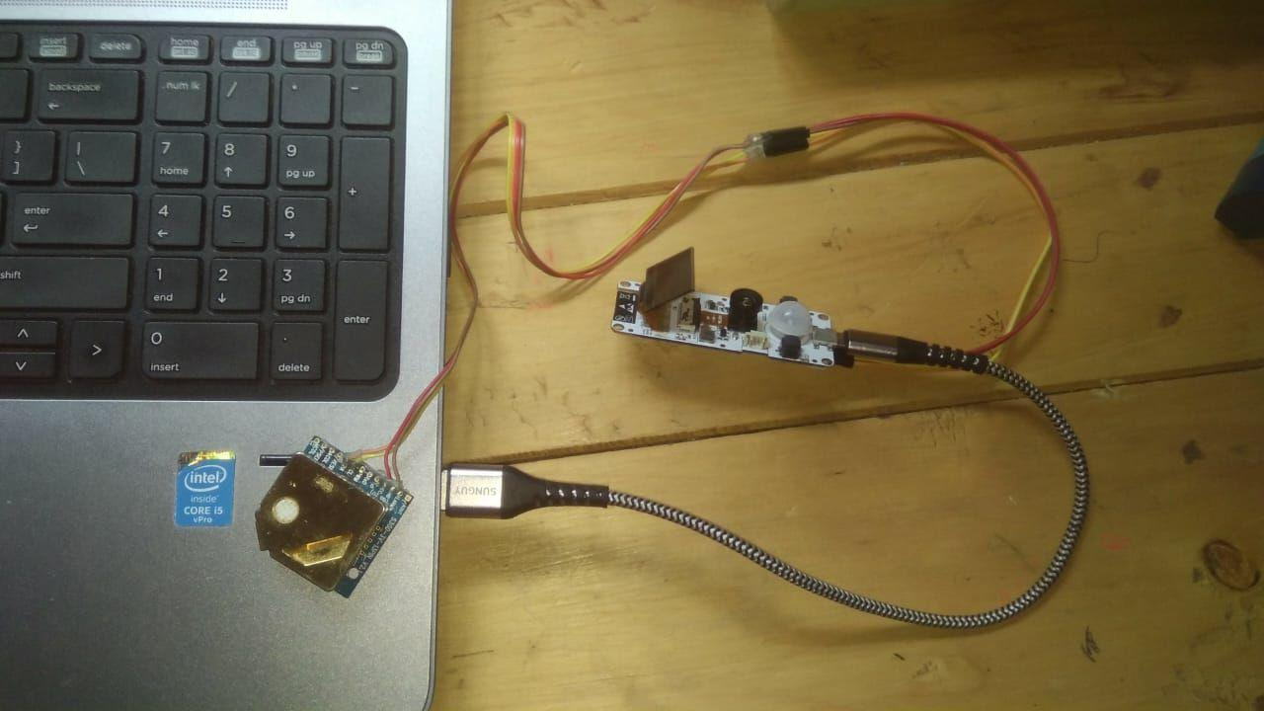

*Figure 7: Hardware setup*

### 4.1.2 Software setup

Arduino IDE was used to generate codes to run the system. Several libraries had to be downloaded to the ESP32 module to enable interactions with the sensors and platforms. The libraries provided hardware connection with:

* OV2460 camera
* OLED Display
* PIR motion sensor
* WiFi module
* CO2 sensor
* Google Firebase platform
* Thingspeak IOT platform

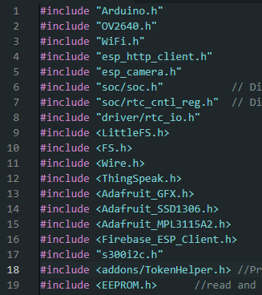

*Figure 8:Libraries used in the project*

## 4.2 INTEGRATING IMAGE PROCESSING BY USE OF CNN MACHINE LEARNING MODEL TO INTERPRET AND PROCESS IMAGES.

By use of Machine Learning, we were able to create a Convolution Neural Network(CNN) model. This involved creating a neural network that was to be used to predict and classify images of vehicles as either roadworthy or unroadworthy.

Once the model had been created, we were able to determine the Mean Average Precision(mAP) of the model. The mAP was calculated to be 78.4%. A graph detailing the mAP against epochs was also obtained. The precision of the model was also calculated to be 90.2%.

Mean Average Precision refers to the metric system used to evaluate object detection models such as CNN. A graph of mAP against epochs is shown:

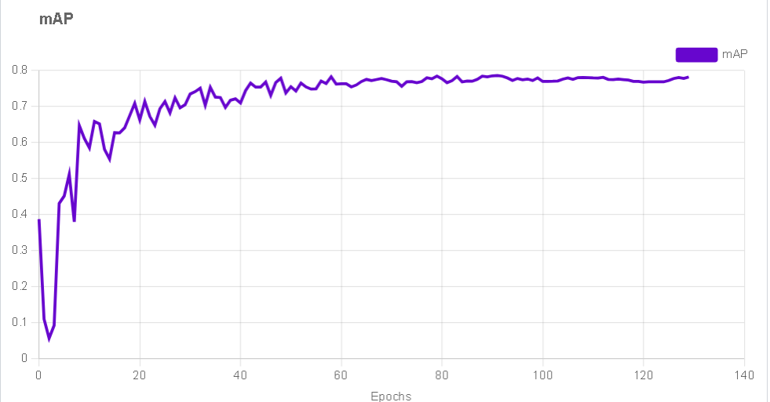

We also evaluated the losses of the model as the training process was being undertaken. We evaluated box loss, class loss and object loss. It was observed that the losses decreased with increasing number of epochs. This proves that the model was improving and increasing efficiency with increase in epochs.

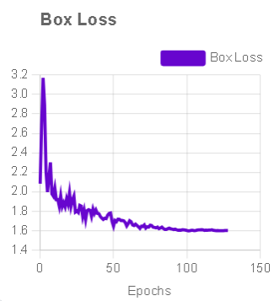 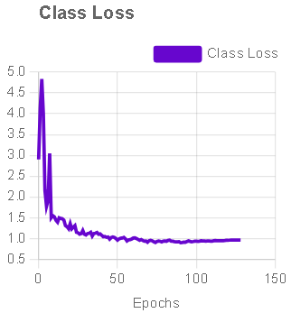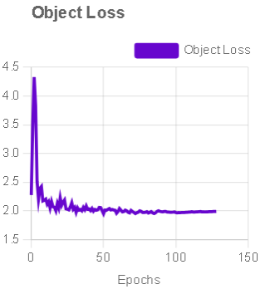

Once the model had been deployed, we inference the images to classify the vehicles as roadworthy or unroadworthy. This resulted in a bounding box created around the vehicle in question and classification occurred as shown:

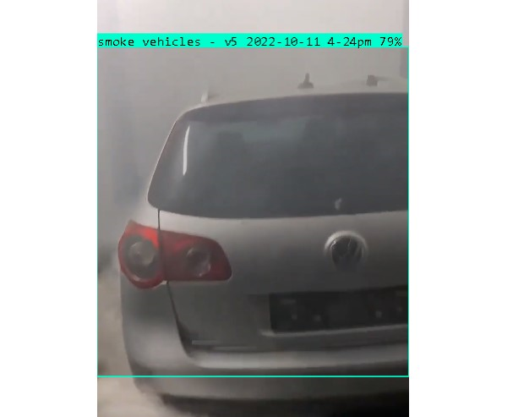

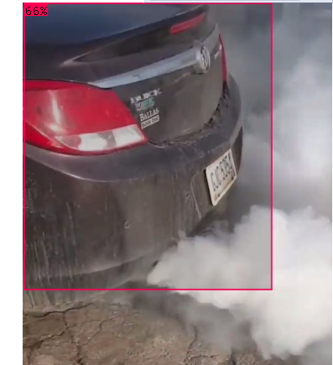

## 

## 4.3 TO INTRODUCE AN IOT SYSTEM FOR DATA PROCESSING, ANALYSIS OF DATA COLLECTED AND STORAGE.

To facilitate efficient data processing, analysis, and storage within our IoT system, we strategically utilized cloud-based platforms ; ThingSpeak and Firebase.The Wi-Fi module on the ESP32 board helped us achieve a robust architecture capable of handling data collection, transmission, analysis, and storage. ThingSpeak, a platform designed for IoT applications, played a pivotal role in our system's functionality. Through the ESP32's Wi-Fi connectivity, we established a direct channel to ThingSpeak, enabling real-time data transmission of CO2 readings and PIR motion triggers. This cloud-based platform efficiently stored the incoming data, offering robust visualization tools and analytics capabilities. Furthermore, we integrated Firebase, a powerful real-time database platform, into our system architecture. Firebase provided a secure and scalable environment for storing and managing image data generated by the OV2460 camera. By using ThingSpeak and Firebase along with the Wi-Fi capabilities of the ESP32 board, we made our system really efficient at dealing with data. These cloud platforms helped us process, analyze and store information in a way that was smooth and could grow as we needed it to.

## 

## 

*Figure 8: PIR readings and CO2 reading on our thingspeak channel*

# CHAPTER FIVE : CONCLUSION AND RECOMMENDATION

The study successfully addressed the outlined objectives by achieving significant milestones in each facet. Objective 1,using sensor technologies and cameras to collect data which include images and Carbon (II) Oxide levels. Through the integration of sensor technology we were able to collect data, analyze it and therefore justify the working principle of our project.Objective 2, centered around integrating image processing by use of CNN machine learning model to interpret and process images, was effectively realized. Through the integration of image processing within the machine learning framework, the system showcased a notable improvement in detecting emission levels visible in photos. The model had an accuracy of 92%, substantiating the project's commitment to enhancing identification capabilities.Objective 3 involved creating an IOT system between the hardware setup and cloud platforms which was achieved. The integration IOT made real time monitoring and data analysis achievable.

While the project significantly advanced the identification of unroadworthy vehicles, certain areas could benefit from future research endeavors. Upgrading the system's computational efficiency to handle larger datasets in real-time scenarios remains a crucial area for improvement. Collaborative efforts with the system’ innovators and enforcement boards such as NTSA ( National Transport and Safety Authority), KENHA( Kenya National Highway Authority) and rural and urban road authorities. Collaborating with these government authorities may help enhance the technical aspects of our project and also ensure alignment with regulatory requirements, potentially facilitating smoother implementation and greater impact within the transport sector in Kenya.

# REFERENCES

# 

1. Dogan Ibrahim. *The Complete ESP32 Projects Guide : 59 Experiments with Arduino IDE and Python*. London, Elektor, 2019.
2. Filonchyk, Mikalai, and Michael Peterson. “Air Quality Changes in Shanghai, China, and the Surrounding Urban Agglomeration during the COVID-19 Lockdown.” *Journal of Geovisualization and Spatial Analysis*, vol. 4, no. 2, 23 Oct. 2020, https://doi.org/10.1007/s41651-020-00064-5. Accessed 10 Nov. 2020.
3. Gu, Ke, et al. “Deep Dual-Channel Neural Network for Image-Based Smoke Detection.” *IEEE Transactions on Multimedia*, vol. 22, no. 2, 1 Feb. 2020, pp. 311–323, ieeexplore.ieee.org/abstract/document/8764415, https://doi.org/10.1109/TMM.2019.2929009. Accessed 3 Nov. 2022.
4. Jiao, Licheng, et al. “A Survey of Deep Learning-Based Object Detection.” *IEEE Access*, vol. 7, 2019, pp. 128837–128868, https://doi.org/10.1109/access.2019.2939201. Accessed 31 Mar. 2020.
5. Kan, Haidong, et al. “Health Impact of Outdoor Air Pollution in China: Current Knowledge and Future Research Needs.” *Environmental Health Perspectives*, vol. 117, no. 5, May 2009, https://doi.org/10.1289/ehp.12737. Accessed 20 July 2019.
6. Krizhevsky, Alex, et al. “ImageNet Classification with Deep Convolutional Neural Networks.” *Communications of the ACM*, vol. 60, no. 6, 24 May 2012, pp. 84–90, https://doi.org/10.1145/3065386.
7. Madhumathy P, et al. *Machine Learning and IoT for Intelligent Systems and Smart Applications*. CRC Press, 17 Nov. 2021.
8. Millstein, Frank. *Machine Learning with Tensorflow*. Frank Millstein, 3 July 2020.
9. Rajesh Doriya, et al. *Machine Learning, Image Processing, Network Security and Data Sciences*. Springer Nature, 1 Feb. 2023.
10. Rodríguez-Urrego, Daniella, and Leonardo Rodríguez-Urrego. “Air Quality during the COVID-19: PM2.5 Analysis in the 50 Most Polluted Capital Cities in the World.” *Environmental Pollution*, vol. 266, Nov. 2020, p. 115042, https://doi.org/10.1016/j.envpol.2020.115042. Accessed 18 Sept. 2020.
11. Secker, Benjamin. “Development of an IoT System for Environmental Monitoring: Software.” *Open Access Victoria University of Wellington | Te Herenga Waka (Figshare)*, 1 Feb. 2021, https://doi.org/10.26686/wgtn.13557857. Accessed 20 Sep. 2023.
12. Srivastava, Sudhakar, et al. “21-Day Lockdown in India Dramatically Reduced Air Pollution Indices in Lucknow and New Delhi, India.” *Bulletin of Environmental Contamination and Toxicology*, vol. 105, no. 1, 3 June 2020, pp. 9–17, https://doi.org/10.1007/s00128-020-02895-w. Accessed 8 Jan. 2021.
13. Vedat Ozan Oner. *Developing IoT Projects with ESP32*. Packt Publishing Ltd, 13 Sep. 2021.
14. Zong Chen, Joy Iong. “Automatic Vehicle License Plate Detection Using K-Means Clustering Algorithm and CNN.” *March 2021*, vol. 3, no. 1, 10 May 2021, pp. 15–23, https://doi.org/10.36548/jeea.2021.1.002. Accessed 11 Feb. 2022.